Dear Sir / Madam,

As a general secondary student in the field of science, I am seeking to work in the sectors that develop my personality and that develop the skills of communication with others and that build and develop my current skills. Using the background of my broad knowledge and social identity
After obtaining my secondary degree, I gained my experience in the scientific specialization and through the community service that was in the center of Yusuf Abdul Rahman Al-Mohandes and my studies of a nurse assistant for nine months at King Hamad University Hospital(KHUH) . During my experience I learned how to communicate and work with both sexes (females and males) And how to communicate and deal with all age groups. I have been able to develop some scientific, practical, social and personal skills, work in an excellent team and have a very wide network of contacts. Moreover, you will find that I have a very proactive attitude, I can easily develop a relationship with customers and colleagues with the ability to confidently carry out multiple tasks effectively and achieve the goals and deadlines

If I have the opportunity to work in your esteemed institution, I will be able to integrate with your team and demonstrate that I am worthy of interest and trust with my ambition to achieve established goals. I will devote my personal qualities to progress and the ability to meet business requirements.

I would like to meet with you and your team to continue discussing how to use my skills in your organization and answer any questions you may have. If you would like to contact me regarding my resume, please feel free to contact me at 36883734. I will be at your disposal at any time convenient to you.

Yours faithfully,
Maryah jamal saleh al-mutawaa

Enclosed:
Curriculum Vitae

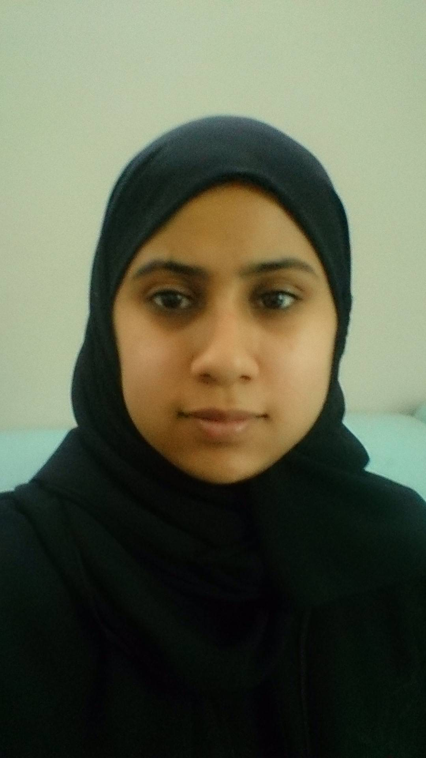
- Name:  - Nationality:  - Address:  - Marital  - Status:  - Date of Birth:  - Contact: | Maryah jamal saleh almutawaa  Bahraini.  Villa-741 Road-2006 -ploke720, zayed town - Bahrain.  Single  10 march 1999  Telephone: 36883734/ 33663644  e-mail: miome00@gmail.com

High school: Secondary Scientific Certificate.
2015-2017 Omayma bint Al Nu'man Secondary Girls School, Isa Town , Bahrain
2018-1019 study in {KHUH} king Hamad University Hospital , busatin , Bahrain ( 9 month ) may 2018 to jan 2019

Excellent verbal and written communication skills in Arabic,
good verbal and written skills in English,
Excellent performance in the team,
Excellent presentation skills
A skilled negotiator,
Very creative mind,
High level of adaptability,

Computer Skill

Advanced level packages of Office (Word, Essis, Excel, Buerpoint),
.

Drawing and graphics
Computers / Internet,
swimming,
Music,
Talent Management.
Writing and poetry
origami
Manual work

* References available upon request.

